Students Social Media Addiction Project

Data Source:
https://www.kaggle.com/datasets/adilshamim8/social-media-addiction-vs-relationships

About Dataset:
Overview
The “Student Social Media & Relationships” dataset contains anonymized records of students’ social‐media behaviors and related life outcomes. It spans multiple countries and academic levels, focusing on key dimensions such as usage intensity, platform preferences, and relationship dynamics. Each row represents one student’s survey response, offering a cross‐sectional snapshot suitable for statistical analysis and machine‐learning applications.

Scope & Coverage
- Population: Students aged 16–25 enrolled in high school, undergraduate, or graduate programs.
- Geography: Multi‐country coverage (e.g., Bangladesh, India, USA, UK, Canada, Australia, Germany, Brazil, Japan, South Korea).
- Timeframe: Data collected via a one‐time online survey administered in Q1 2025.
- Volume: Configurable sample sizes (e.g., 100, 500, 1,000 records) based on research needs.

Data Collection & Methodology
- Survey Design: Questions adapted from validated scales on social‐media addiction (e.g., Bergen Social Media Addiction Scale) and relationship conflict indices.
- Recruitment: Participants recruited through university mailing lists and social‐media platforms, ensuring diversity in academic level and country.
- Data Quality Controls:
  - Validation: Mandatory fields and range checks (e.g., usage hours between 0–24).
  - De‐duplication: Removal of duplicate entries via unique Student_ID checks.
  - Anonymization: No personally identifiable information collected.

Key Variables:

Variable | Type | Description
Student_ID | Integer | Unique respondent identifier
Age | Integer | Age in years
Gender | Categorical | “Male” or “Female”
Academic_Level | Categorical | High School / Undergraduate / Graduate
Country | Categorical | Country of residence
Avg_Daily_Usage_Hours | Float | Average hours per day on social media
Most_Used_Platform | Categorical | Instagram, Facebook, TikTok, etc.
Affects_Academic_Performance | Boolean | Self‐reported impact on academics (Yes/No)
Sleep_Hours_Per_Night | Float | Average nightly sleep hours
Mental_Health_Score | Integer | Self‐rated mental health (1 = poor to 10 = excellent)
Relationship_Status | Categorical | Single / In Relationship / Complicated
Conflicts_Over_Social_Media | Integer | Number of relationship conflicts due to social media
Addicted_Score | Integer | Social Media Addiction Score (1 = low to 10 = high)

Potential Analyses
- Correlation Studies: Examine associations between daily usage hours and sleep hours.
- Predictive Modeling: Build classifiers to predict relationship conflicts based on usage patterns and platform type.
- Clustering: Identify user segments (e.g., “high‐usage high‐stress” vs. “moderate‐usage balanced”).

Limitations
- Self‐Report Bias: All measures are self‐reported and may be subject to social‐desirability effects.
- Cross‐Sectional Design: One‐time survey prevents causal inference.
- Sampling Variability: Recruitment via online channels may underrepresent students with limited internet access.

Calculated Fields Used in the Dashboard

1. Addiction_Level

Purpose:
To classify the addiction score into clear categories (Low / Moderate / High) for easier and more structured analysis.
Formula:
IF [Addicted Score]>=8 THEN "high"
ELSEIF [Addicted Score]>=5 THEN "moderate"
ELSE "low"
END
Based on predefined total addiction score ranges.
Use:
Used to compare usage patterns across different addiction levels and identify group differences.

2. Academic_Year

Purpose:
To analyze how addiction levels change across academic progression (from first year to later years).
Formula:
IF [Age] <19 THEN "high school"
ELSEIF [Age] <= 20 THEN "first year"
ELSEIF [Age] < 22 THEN "second year"
ELSEIF [Age] < 23 THEN "third year"
ELSE "graduation Year"
END
Use:
Used in line charts to observe trends and patterns across academic years.

3. Sleep_Percentage

Purpose:
To measure how close the actual sleep duration is to the recommended 8 hours of sleep per night.
Formula:
([Sleep Hours Per Night] / 8) * 100
Use:
Used to evaluate sleep regularity and examine whether sleep patterns differ across addiction levels.

4. Sleep_Category

Purpose:
To convert the numerical Sleep_Percentage into meaningful categories (very low\ less than normal \ normal \ more than normal) for clearer interpretation.
Formula:
IF [sleep_percentage] < 70 THEN "very low"
ELSEIF [sleep_percentage] < 90 THEN "less than normal"
ELSEIF [sleep_percentage] <= 110 THEN "normal"
ELSE "more than normal"
END
Use:
Used in comparative tables to assess sleep quality and identify patterns linked to addiction severity.

Questions:

1-Is there a relationship between the level of addiction and the average daily usage hours of social media platforms?

2-How does the rate of social media usage change with academic progression?

3-Does the rate of social media usage differ between males and females?

4-Does the level of academic performance get affected by the rate of daily hours of social media usage?

5-Which platforms are associated with higher daily usage hours?

6-How are daily sleep hours distributed across addiction levels?

Visualization

Q1-Is there a relationship between the level of addiction and the average daily usage hours of social media platforms?

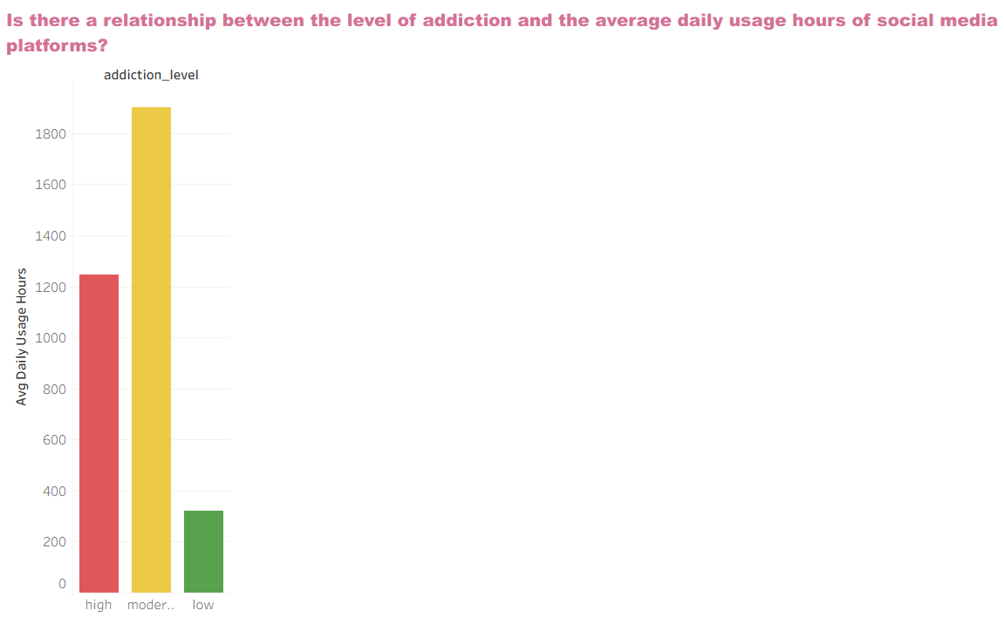

Most students fall within the moderate addiction category, which indicates that social media has become an essential part of their daily lives, yet still remains under control. However, the moderate level is considered a “risk zone” because it can gradually develop into real addiction as daily usage hours increase.
Low addiction may result from higher awareness among some students, or more commonly from academic or household restrictions that limit excessive use.

Proposed Solutions:
1-Encourage real-life activities on or off campus.
2-Offer workshops on digital time-management, especially targeting the moderate-addiction group.

Q2-How does the rate of social media usage change with academic progression?

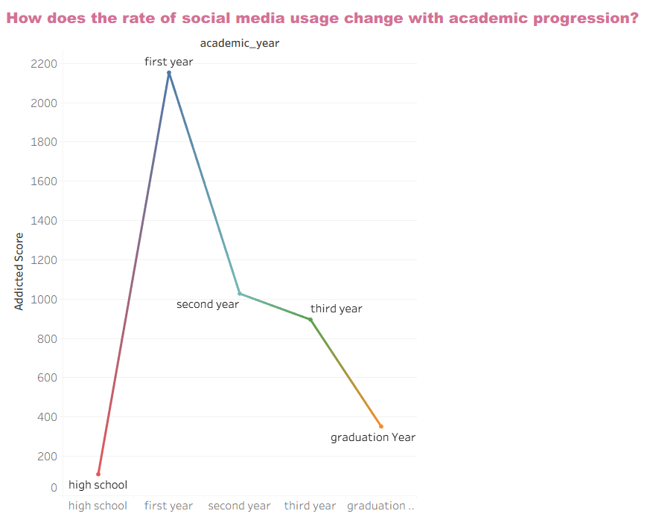

First-year students may spend more time on social media due to the sense of new freedom after school, their need to build new friendships, and the process of adjusting to university life.
In contrast, students in later years develop different priorities such as internships or part-time jobs, which reduces their usage.

Discussion Question:
Is the high increase in social media use during the first year a natural sign of adjustment, or a problem requiring awareness and time-management strategies?
And how can universities support new students so that the adjustment process does not turn into addiction?

Suggestions:
1- Provide orientation sessions for first-year students about balancing digital and academic life.
2- Encourage university clubs and real-life activities as a healthier alternative to excessive online engagement.
3-Monitor addiction indicators among new students and follow up with psychological support and time-management programs.
4- Conduct mid-year assessments of social media use to measure behavioral improvement as academic progress advances.

Q3-Does the rate of social media usage differ between males and females?

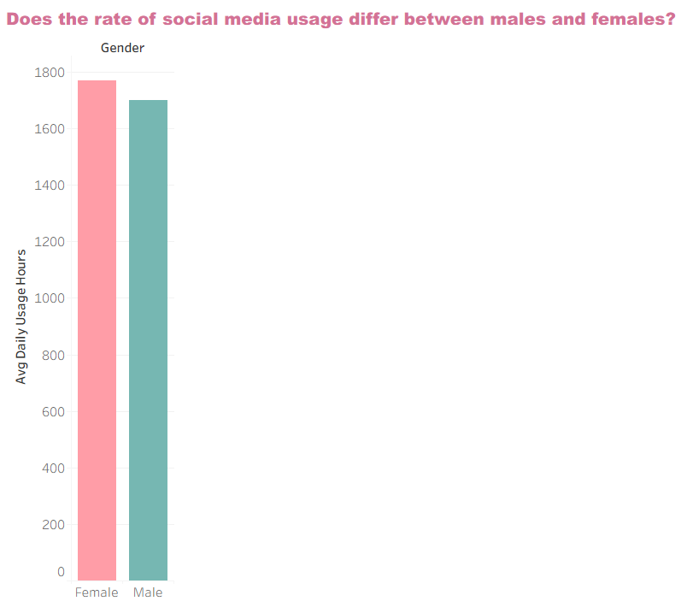

In the past, some studies showed a clear difference favoring females.
This slight difference may be explained by females’ tendency toward social interaction and communication on platforms, while males may use them more for following content or gaming rather than posting.

Discussion Question:
Why has the gap between males and females in social media usage decreased?
Does this reflect positive digital equality, or simply a general increase in addiction among both groups?

Suggestions:
1- Strengthen awareness programs targeting both genders rather than one group.
2- Focus on quality, not just quantity, of usage (how to use social media time productively).
3- Create joint digital-balance campaigns targeting all youth.
4- Train students in “conscious use” instead of imposing bans or restrictions.

Q4-Does the level of academic performance get affected by the rate of daily hours of social media usage?

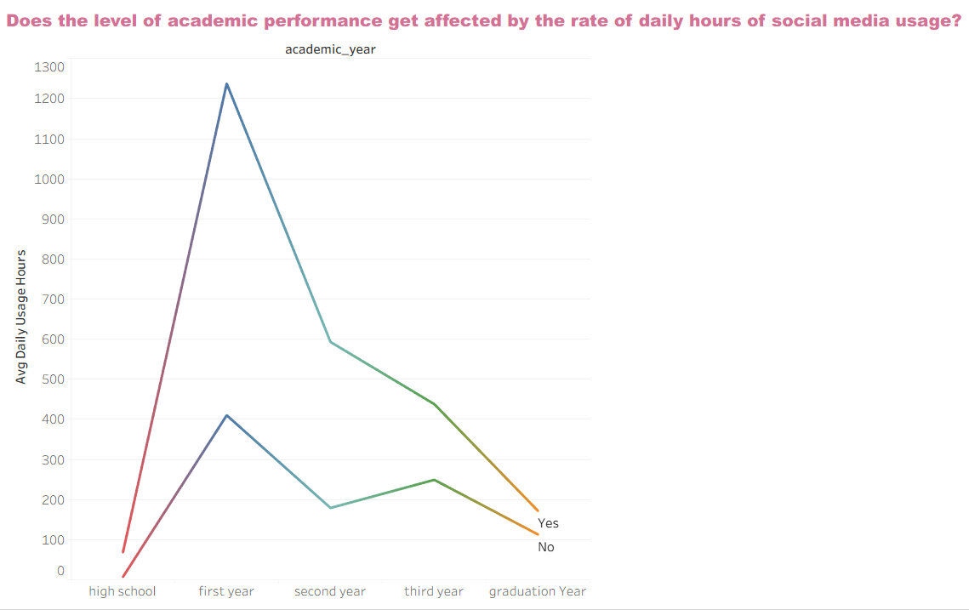

Students who spend less time online experience far less impact on performance.
The relationship is clearly inverse: excessive use reduces study time and sleep and increases mental distraction during learning.
Students who are aware and manage their time well can use social media moderately without negative effects.

Discussion Question:
Is the problem in the amount of time, or in the type of usage?
And can social media be used in educational rather than entertainment ways to reduce negative impacts?

Suggestions:
1- Train students in digital time-management (setting specific times for using social media).
2- Encourage using educational platforms instead of entertainment ones during study hours.
3- Encourage students to try a “no social media week” to observe improvements in focus and performance.

Q5- Which platforms are associated with higher daily usage hours?

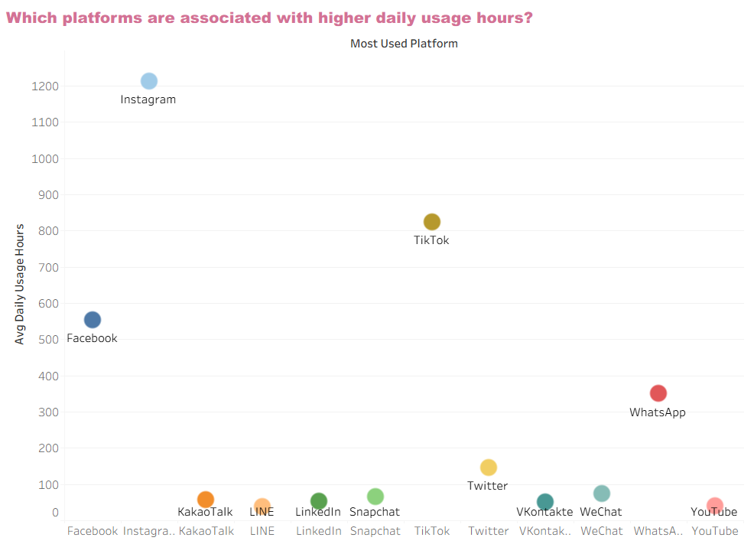

Platforms based on fast visual content (Reels, Shorts) have a stronger effect on addiction.
The main reason is that Instagram and TikTok provide personalized, highly entertaining content, making users spend long periods without realizing it.
This triggers instant gratification, one of the strongest psychological factors behind digital addiction.
Meanwhile, WhatsApp and Facebook are used more for communication or sharing information rather than entertainment.

Suggested Solutions:
1- Raise awareness about the risks of getting absorbed in repetitive short-form content.
2- Set limits on daily usage duration.
3- Replace entertainment time with educational content (courses, awareness pages).
4- Promote purposeful use (for example, using Instagram to share academic projects or university activities).

Q6- How are daily sleep hours distributed across addiction levels?

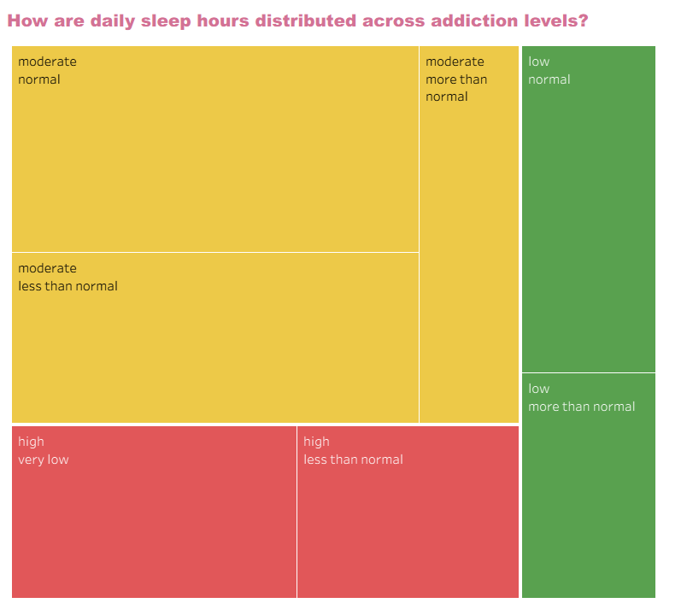

I used the standard deviation to observe the level of variability in students’ sleep within each addiction level. This gives a more realistic view of how stable or disturbed sleep patterns are at each level.
In the "moderate group", students are distributed between (normal and more\less than normal sleep), which means some of them sleep enough while others are starting to be affected.
In the "high addiction group", students are distributed between (very low and less than normal sleep), meaning that individuals with high addiction clearly suffer from reduced sleep, and their sleep patterns are often irregular.
In the "low addiction group", students are distributed between (normal and more than normal sleep), which is very logical because people who do not use social media much tend to sleep more hours.

As addiction levels increase, sleep hours decrease.
Students who spend long hours on social media typically use it at night, leading to delayed sleep and reduced rest.
Lack of sleep causes reduced focus and a negative mood, which can push students back to social media as a temporary comfort creating a (closed cycle of addiction).
Some students also use social media as a bedtime habit, which prolongs staying awake even without realizing it.

Proposed Solutions:
1- Set a no-phone time 30–60 minutes before sleep.
2- Activate screen-time limit settings for apps.
3- Encourage students to replace nighttime scrolling with habits like reading, pray, meditation, or calm music.

Analysis of Social Media Addiction Using an Interactive Tableau Dashboard

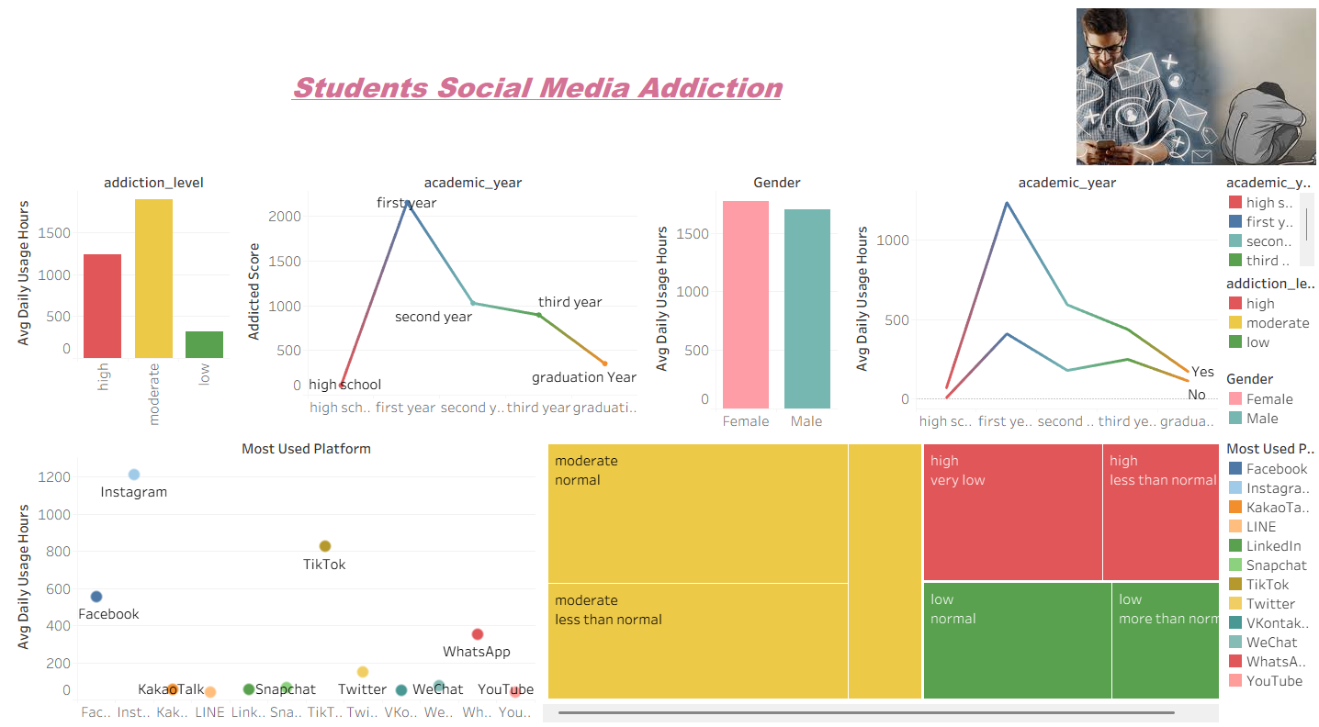

Impact of Instagram Usage on Addiction, Academic Performance, and Sleep

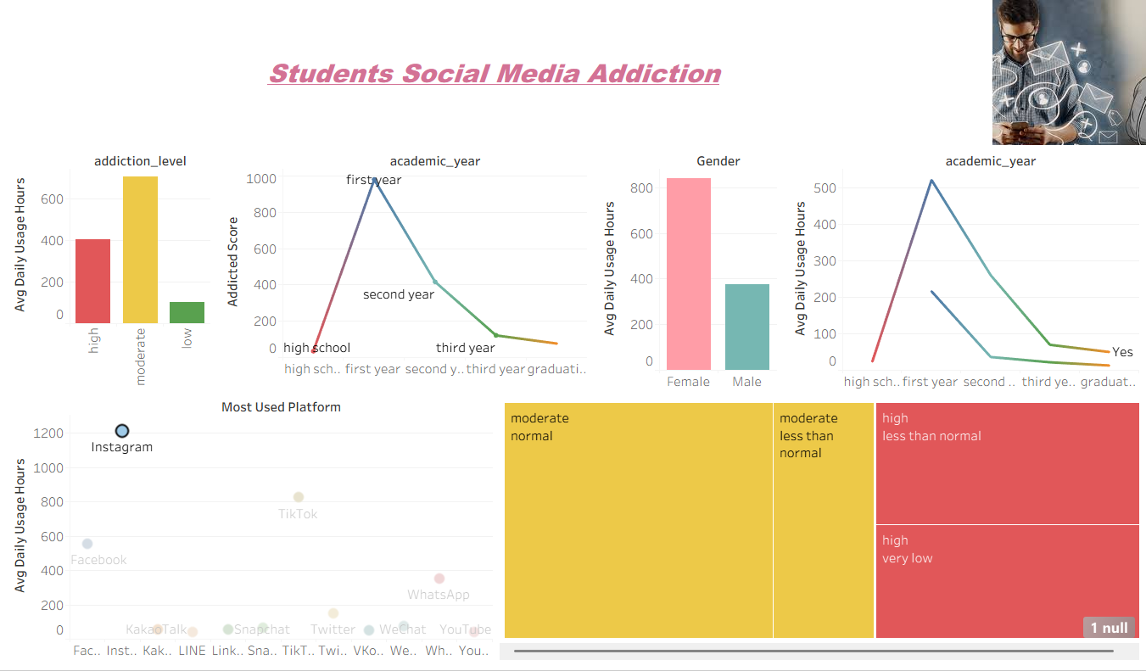

Males vs. Females:
When filtering by Instagram users only, females show a noticeably higher usage level, indicating that Instagram-based addiction is more prevalent among female users compared to males.

Academic Performance:
students with no academic impact (especially at the high school level) disappear, suggesting that intensive Instagram usage is strongly associated with academic performance decline.

Tree Map:
The absence of the low addiction category after filtering indicates that heavy Instagram users predominantly fall into moderate or high addiction levels, which aligns with reduced sleep duration.

Impact of TikTok Usage on Addiction, Academic Performance, and Sleep

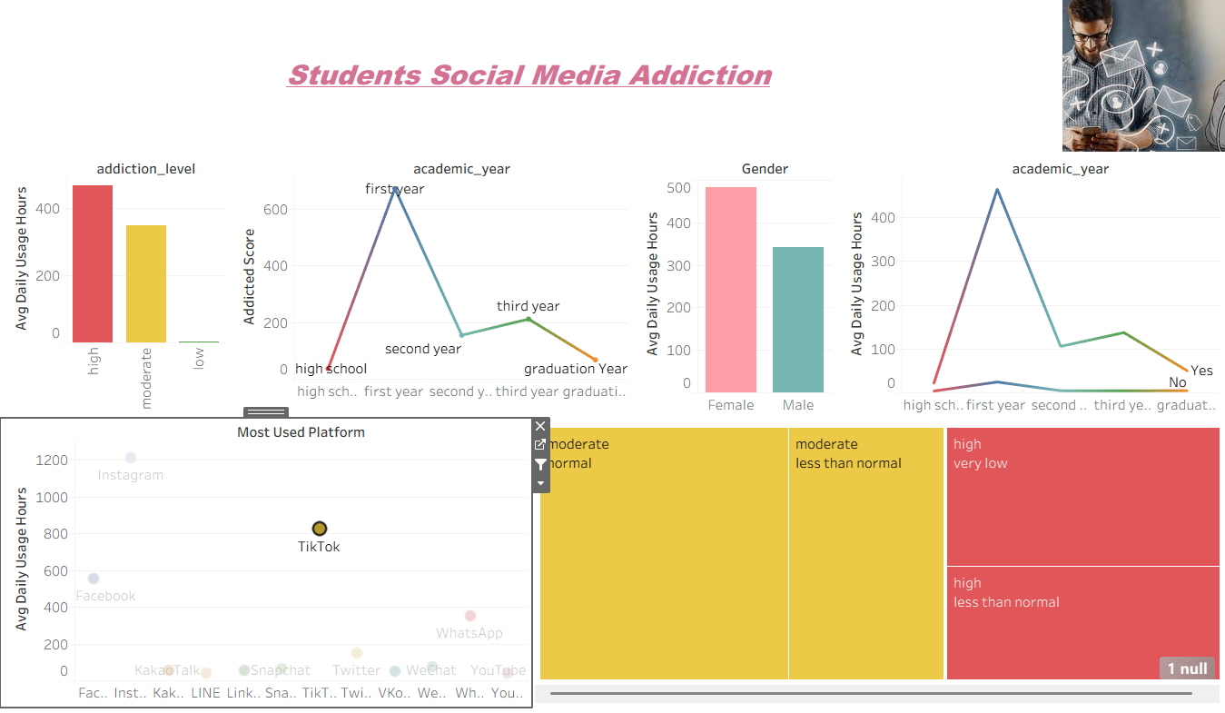

Addiction Level:
When filtering by TikTok users, the proportion of high addiction increases significantly, while low addiction nearly disappears, indicating a stronger addictive design compared to other platforms.

Academic Performance:
The nearly flat and reduced “not affected” trend suggests that TikTok usage impacts academic performance consistently across different academic years.

Tree Map:
The disappearance of low addiction sleep patterns highlights that TikTok users are more likely to experience disrupted sleep associated with moderate to high addiction levels.

Impact of Facebook Usage on Addiction, Academic Performance, and Sleep

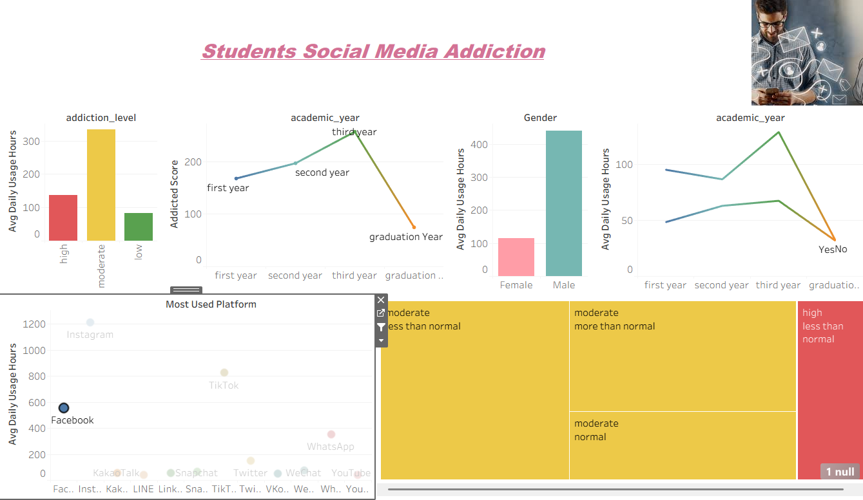

Academic Year:
Facebook usage shows a gradual increase from the first to the third academic year, followed by a sharp decline in the graduation year, indicating a shift in priorities as students approach program completion.

Male vs. Female:
When focusing on Facebook users, males show significantly higher usage rates than females, highlighting a clear gender preference for the platform.

Academic Performance:
The dominance of the “Not Affected” category suggests that Facebook usage is associated with minimal academic performance impact, particularly during the second academic year.

Tree Map:
The absence of low addiction sleep patterns indicates that active Facebook users predominantly fall within moderate to high addiction levels, although sleep disruption appears less severe compared to entertainment-driven platforms.

Impact of LinkedIn Usage on Addiction, Academic Progression, and Sleep

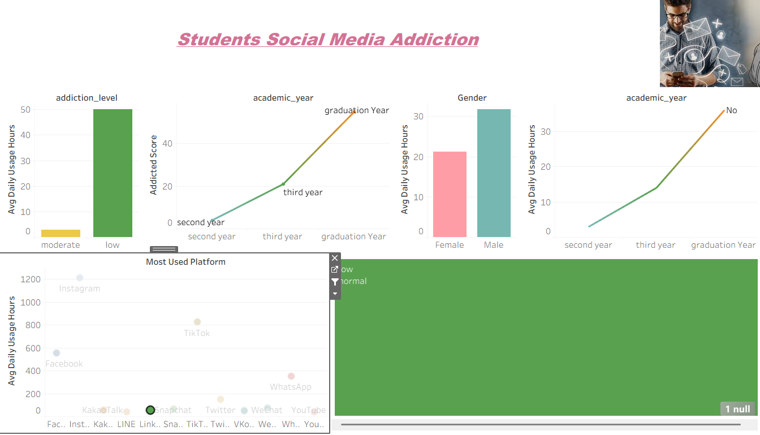

Addiction Level:
When filtering by LinkedIn usage, addiction levels shift dramatically toward low addiction, with high and moderate addiction becoming nearly absent.

Academic Year:
LinkedIn usage increases steadily from the second academic year through graduation, reflecting growing career-oriented engagement among senior students.

Male vs. Female:
LinkedIn usage is higher among males than females, indicating a gender difference in engagement with professional networking platforms.

Tree Map:
Sleep patterns among LinkedIn users remain largely within normal ranges, with minimal sleep disruption observed.

Impact of Social Media Usage Patterns Among Female Students

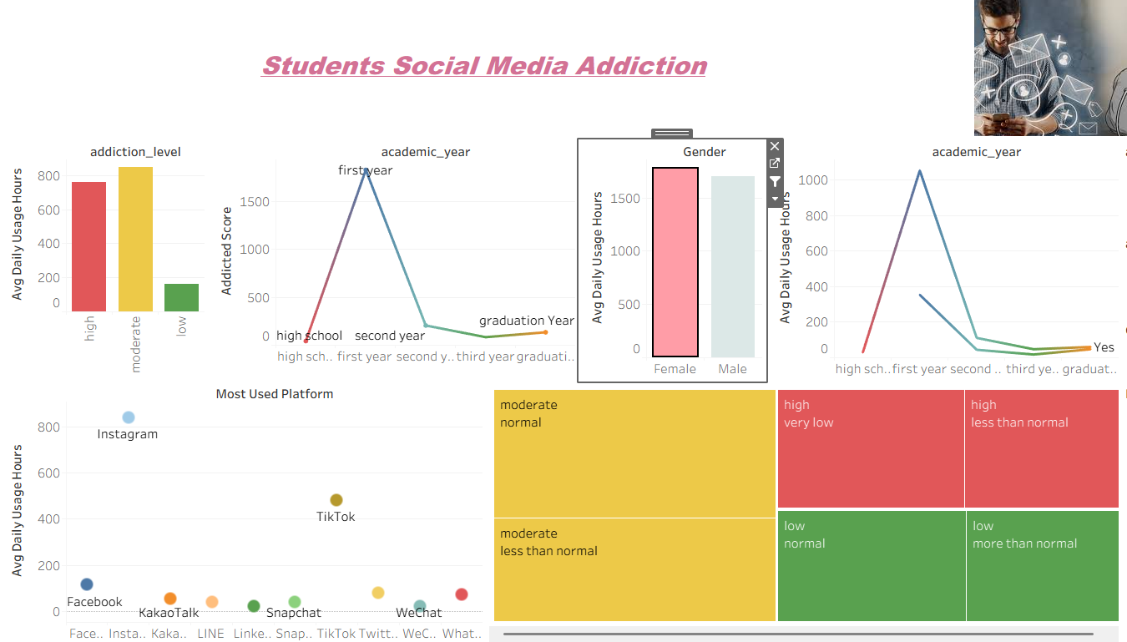

Academic Year:
The analysis shows a pronounced peak in social media usage during the first academic year among female students, followed by a sharp decline in later years. This pattern suggests that first-year females may rely more heavily on social media for social adaptation and emotional support during the transition into higher education.
Academic Performance:
Within the “Not Affected” category, high school students disappear, while the remaining academic years show minimal change. This indicates that female students who maintain controlled usage are less likely to experience academic performance issues, particularly beyond the early academic stages.

Platform Used:
Instagram and TikTok clearly dominate platform usage among females, while Facebook and WhatsApp usage decline significantly and align with other less-used applications. This highlights a strong preference for visually driven and interactive platforms among female users.

Impact of Social Media Usage Patterns Among Males Students

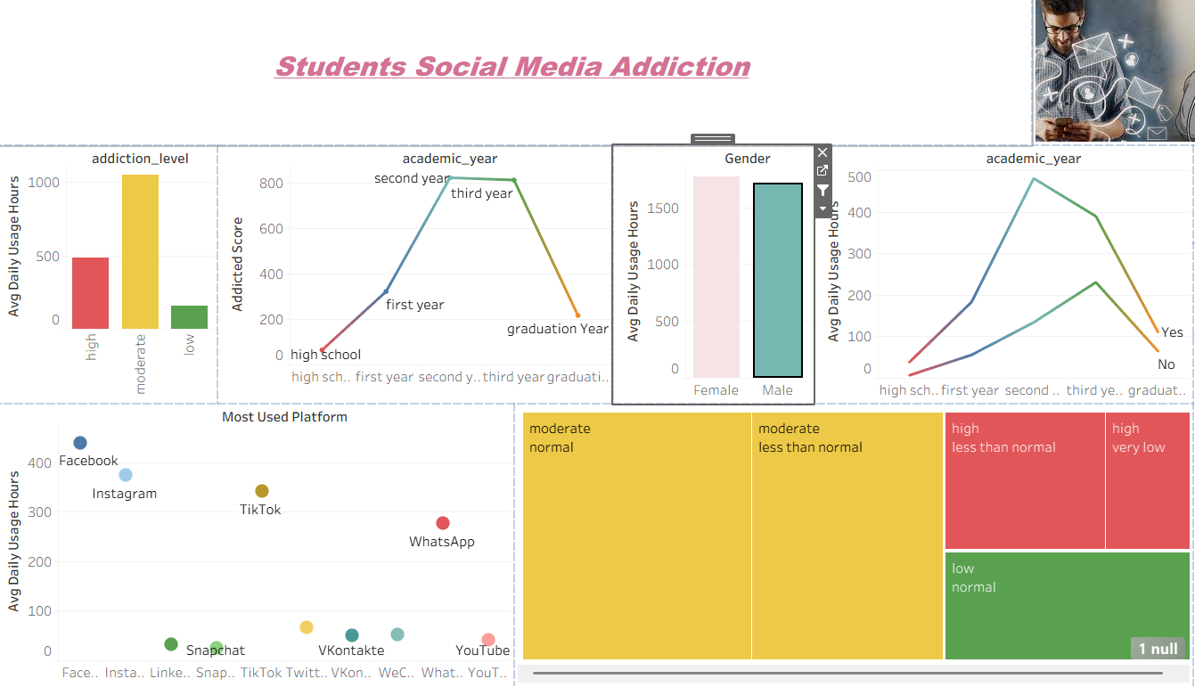

Academic Year:
The analysis shows that social media usage peaks during the second and third academic years among male students, with both years displaying similarly high levels of engagement. Usage levels are noticeably lower in the remaining academic years, suggesting a concentration of social media activity during the mid-academic stage.

Academic Performance:
An increase is observed in both the “Affected” and “Not Affected” categories, indicating greater variability in academic outcomes among male users. This suggests that while some male students experience academic impact from social media usage, others are able to maintain their performance despite high engagement.

Tree Map:
Moderate sleep disruption is significantly higher among male students, whether sleep duration is normal or less than normal. The absence of “More than normal” sleep within moderate addiction suggests increased usage during late hours without compensatory sleep. Among low addiction users, sleep patterns remain mostly within normal ranges.

Females:
  - First-year peak
  - Instagram & TikTok dominant
Males:
  - Second & third-year peak
  - Higher variability in academic impact
  - Moderate sleep disruption

Insights & Analysis

The dashboard reveals clear patterns in student social media behavior and its impacts.

Most students fall into a moderate addiction range a concerning “risk zone” that can escalate with increasing hours online.

First-year students show the highest usage, likely due to social adjustment, while usage declines across later academic years.

Gender differences are minimal, indicating the behavior is widespread.

Higher addiction levels correlate with poorer academic performance and reduced sleep.

Platforms delivering short, highly engaging visual content (e.g., TikTok, Instagram) are most strongly associated with addiction.

Overall, the interactive dashboard enables quick comparison across groups and platforms, highlighting where interventions (time-management workshops, campus activities, targeted awareness) could be most effective.
With longitudinal or psychological data, future analyses could better track change over time and causal links.

